GPIOs Freed by Disabling Features:
- SD Card Pins (12, 13, 14, 15, 02, 04 ): If you do not use the SD card, these pins can be freed for other purposes.
- KEY Pins (5, 18, 19, 23): Buttons are mapped to GPIO 5, 18, 19, 23. These can be used for general IO if the buttons are not required.
Used GPIOs (Audio Codec & Peripheral Management):
- ES8388 Audio Codec: GPIOs 21, 22, 25, 26, 27, 32, 33 are generally used for I2C and I2S communication with the audio chip.
- Amp Enable: GPIO 21 is frequently used for the amplifier mute/enable function.
- LED: GPIO 22 is often used for a green LED (active low).

IO13, IO5, IO18, IO19, I023, IO36

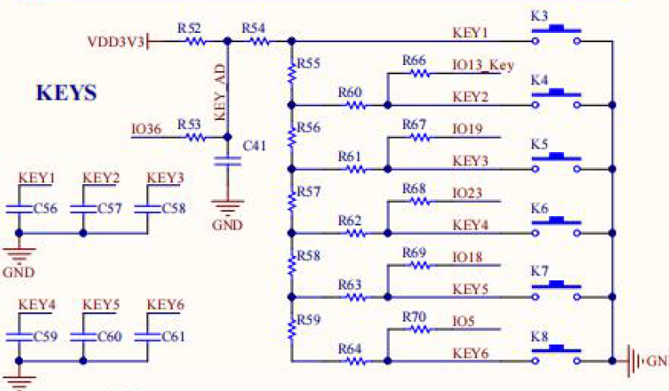

IO5, IO18, IO19, IO21, IO22, IO23 IO19, IO21
